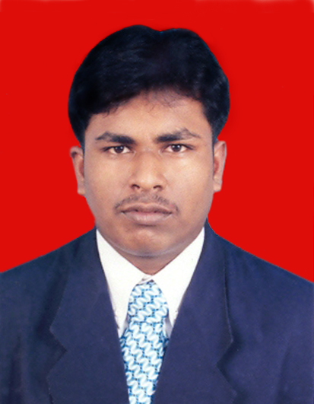
Mr.KOVISHANGER YOGARETNAM
NO.15, 4TH CROSS
THIRAIMADU,
BATTICALOA,
SRILANKA
Cont. No - + 94 785036312, +94 752827029 & +94 655687879
E-mail - yogakobishanger@gmail.com , yogakobish@yahoo.co.in

Career Objective

“To work with an organization where my proven skills and abilities those gained in the past could be utilized for my further career development and be an asset to the company. Emphasizing more on the key areas of daily activities by keeping regular updates with the progressing trends of the industry and hold on a challenging and developing carrier track”

Career Summary

- Skilled in Microsoft Office
Ms Word
Ms Excel
Internet & E-mail
- Preserve a reliable track proof for best performance through own strengths and by guiding and encouraging a progressive enhancement of others
- Consumerist, Self initiative, Creative, Inventive, Professional and superb communicator
- Team Player, Excellent communicator & Possess efficient Problem solving skills
- Quick Learner of new things, Interested in a multi task career
- Good in Tamil Language and able to speak English in Sinhala

Employment History

Project Supervisor
Dye Koneya NGO - 15 August 2005 – 30 March 2009

Office boy
Doha bank – Qatar - 01 September 2005 – 10 December 2009

Asst. team manager
AVIVA NDB Insurance - 01 June 2010 - 14 November 2010

Sales Executive for Hutch
Asia World Marketing Ltd - 16 November 2010 - 15 January 2011

Recovery Officer for Suntel
Asia World Marketing Ltd - 15 January 2011 - 10 April 2012

Sales Supervisor for Mobiles
Asia World Marketing Ltd - 16 April 2012 - 25 June 2012

Sales Repetitive
Vendol Venivel Pvt Ltd - 13 July 2012 - 15 Feb 2013

Area Sales Executive
Master Tea (pvt) Ltd - 01.04.2013 – Still Working

Education Details
Exam - General Certificate of Education (G.C.E)
Level - Ordinary Level (O/L)
Year - December 2001
Index No - # 14829550
Result - Passed with B, 4C & 4S

Subject Standard Obtained
Religion (Hindu) Very Good Pass [B]
Tamil Language Credit Pass [C]
English Language Credit Pass [C]
Commerce Credit Pass [C]
Tamil Literature Credit Pass [C]
Mathematics Simple Pass [S]
Science Simple Pass [S]
Social Studies Simple Pass [S]
Health Science Simple Pass [S]

General Certificate of Educational (G.C.E-Advanced Level) - 2004
BT/ Hindu College, Batticaloa
G.C.E A/L (2004)
Art section studied 3subject (Tamil, Logic & Hinduism) including English for 2 years.

Information Technology (IT)

Name of Institution Course

- International Business System Overseas (pvt)Ltd Ms Office+ Internet & E-mail

Technical Skills

- Technical Institute’s Air Condition & Refrigeration course followed and obtains full credits

Subject Standard Obtained
Practical Work Credit Pass [C]
Job Experience Credit Pass [C]
Theory Simple Pass [S]
Time Keeping 91%

Extra Activities

- Able to handle E-mail and have an awareness of web searching.
- Proven leadership skills through community activities.
- Conducting statistical analysis.
- Participated the training programme on early childhood development organized by the children’s secretariat of the ministry of child development & women’s affairs.
- Participated in the leadership programme conduct by the National Youth Service.
- Secretary of the Thiraimadu Youth Federation 2011.
- Treasurer of the manmunai Youth Federation 2012.
- Participated in the youth club conducted by the National Youth Service Council.
- Participated in the Flood intervention.
- Posses sri Lankan motor bike driving license.

Skills

- Research Dissertation: Researched both in paper journals and on the internet and library based research.

- Teamwork: I have successfully undertaken various team projects within both academic and non-academic environments.

- Communication: Oral communication skills expressed in presentations. Writing skills developed with essay writing. Greatly enhanced my written and verbal communication skills due to many presentations, assignments, essays and projects required.

- Computing skills: Knowledge of windows, MS-Office using email and the internet.

- Willingness to learn: I am keen to develop my understanding and acquire new skills through employment.

Personal Data

- Full Name - KOVISHANGER YOGARETNAM
- Address - 15, 4Th Cross, Thiraimadu
Batticaloa, Sri lanka
- Date of Birth - Dec 28, 1985
- Gender - Male
- Marital Status - Married
- Nationality - Sri Lankan
- Height - 5’ 9”
- Weight - 95Kg
- Mobile - (94) – 0752827029, 0785036312
- Home - (94) -065 2226650
- E-mail - yogakobishanger@gmail.com
yogakobish@yahoo.co.in

Non Related Referees

- Name : Mr.N.Jegatheesan
Designation : Proprietor
Company Address : SDCL, JRM, Jegatheesan & sons &
Mayruban Agro centre in Batticaloa
Tel : +94 65 22 5699, +94 77 3534642

- Name : Mr.T.Jothiretnam
Designation : Retired Chief Account
Company Address : Post Office in Batticaloa
Tel : +94 65 222 2223

I do hereby declare that the particulars furnished in my curriculum vitae are true and correct to the best of my knowledge.

Yours Sincerely,

………………………………..
Mr.Y.Kovishanger

